- Lexical Analyzer in C:
#include <stdio.h>
#include <ctype.h>
#include <string.h>

int isKeyword(char *word) {
char keywords[][10] = {"int", "float", "char", "if", "else", "while", "for", "return", "void"};
for (int i = 0; i < 9; i++) {
if (strcmp(word, keywords[i]) == 0)
return 1;
} return 0;}
int main() {
char ch, buffer[20];
char input[] = "int a = 10; a = a + 5;"; // Input is predefined
int i = 0, j = 0;
printf("Input code: %s\n\n", input);
printf("Output tokens:\n");
while ((ch = input[i++]) != '\0') {
if (ch == ' ' || ch == '\t' || ch == '\n')
continue;
if (isalpha(ch) || ch == '_') {
j = 0;
buffer[j++] = ch;
while (isalnum(input[i]) || input[i] == '_')
buffer[j++] = input[i++];
buffer[j] = '\0';

if (isKeyword(buffer))
printf("Keyword: %s\n", buffer);
else
printf("Identifier: %s\n", buffer); }
else if (isdigit(ch)) {
j = 0;
buffer[j++] = ch;
while (isdigit(input[i]))
buffer[j++] = input[i++];
buffer[j] = '\0';
printf("Constant: %s\n", buffer); }
else if (ch == '+' || ch == '-' || ch == '*' || ch == '=' || ch == '<' || ch == '>') {
printf("Operator: %c\n", ch); }
else {
if (ch != ' ' && ch != '\n' && ch != '\t')
printf("Symbol: %c\n", ch); }
} return 0;
}
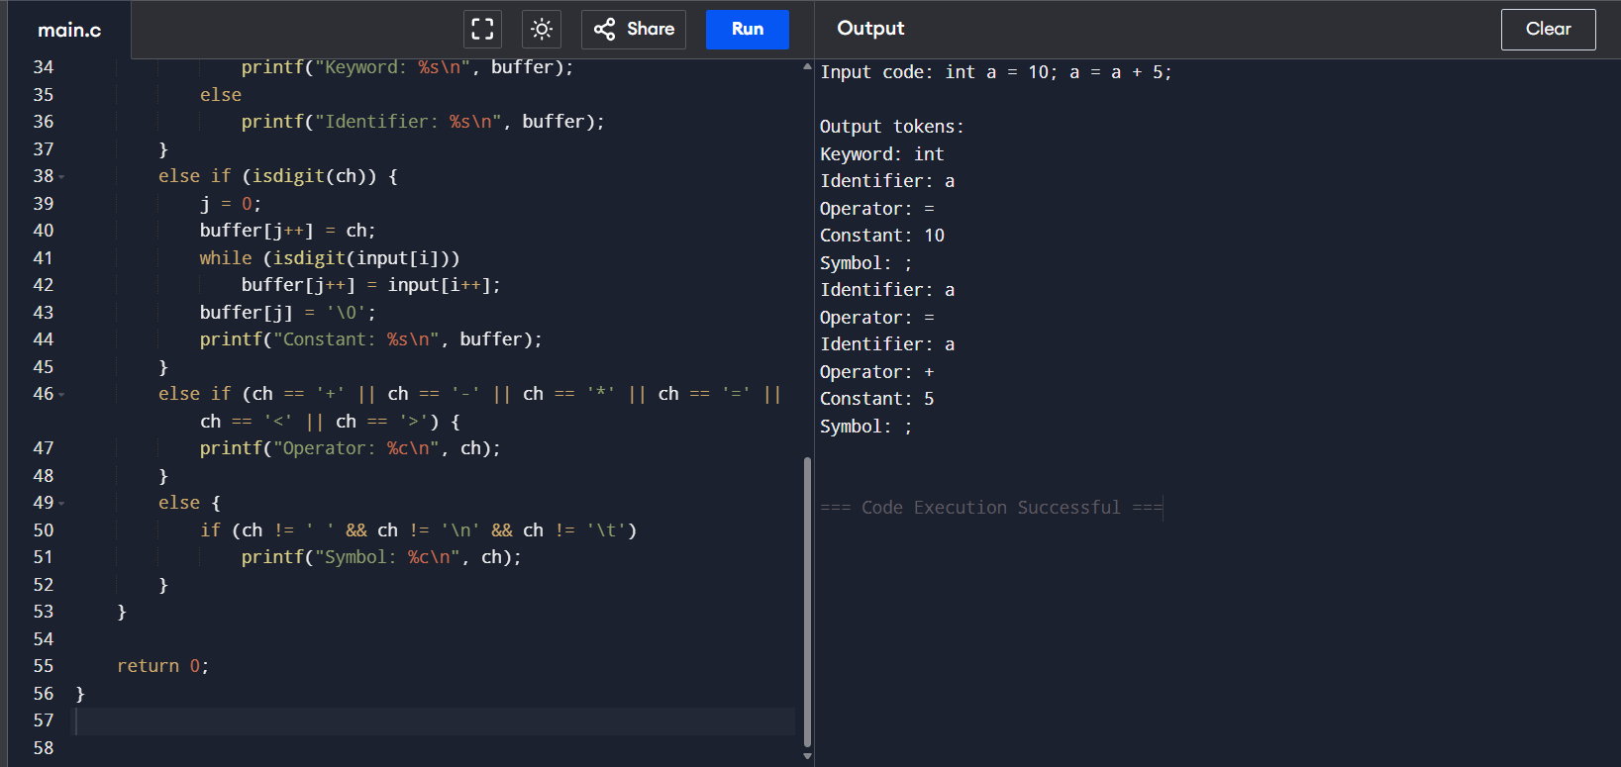
OUTPUT:

- Lexical Analyzer to Identify Comments in C:

#include <stdio.h>
#include <string.h>

int main() {
char line[200];

// Predefined input examples (you can modify this)
char inputs[][200] = {
"// This is a single-line comment",
"/* This is a multi-line comment */",
"int a = 10;",
"/* Multi-line \n comment example */"
};

for (int k = 0; k < 4; k++) {
strcpy(line, inputs[k]);

printf("\nInput: %s\n", line);

if (line[0] == '/' && line[1] == '/') {
printf("Output: It is a single-line comment\n");
}
else if (line[0] == '/' && line[1] == '*') {
int len = strlen(line);
if (len >= 4 && line[len - 2] == '*' && line[len - 1] == '/')
printf("Output: It is a multi-line comment\n");
else
printf("Output: It is an unclosed multi-line comment\n");
}
else {
printf("Output: It is not a comment\n");
}
}

return 0;
}
OUTPUT:

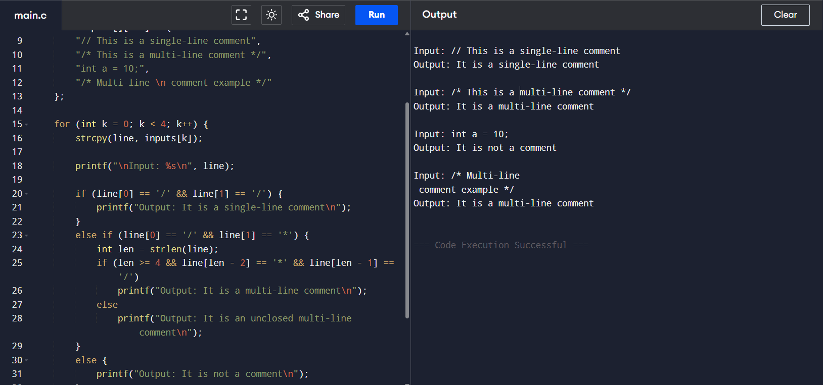

3) Lexical Analyzer to Validate and Recognize Arithmetic Operators in C:

#include <stdio.h>
#include <string.h>

int main() {
// Input defined in the code
char exp[] = "a + b - c * d / e";
int i;

printf("Expression: %s\n", exp);
printf("\nRecognized Operators:\n");

for (i = 0; i < strlen(exp); i++) {
switch (exp[i]) {
case '+':
printf("'%c' → Addition Operator\n", exp[i]);
break;
case '-':
printf("'%c' → Subtraction Operator\n", exp[i]);
break;
case '*':
printf("'%c' → Multiplication Operator\n", exp[i]);
break;
case '/':
printf("'%c' → Division Operator\n", exp[i]);
break;
default:
// ignore all other characters
break;
}
}

return 0;
}

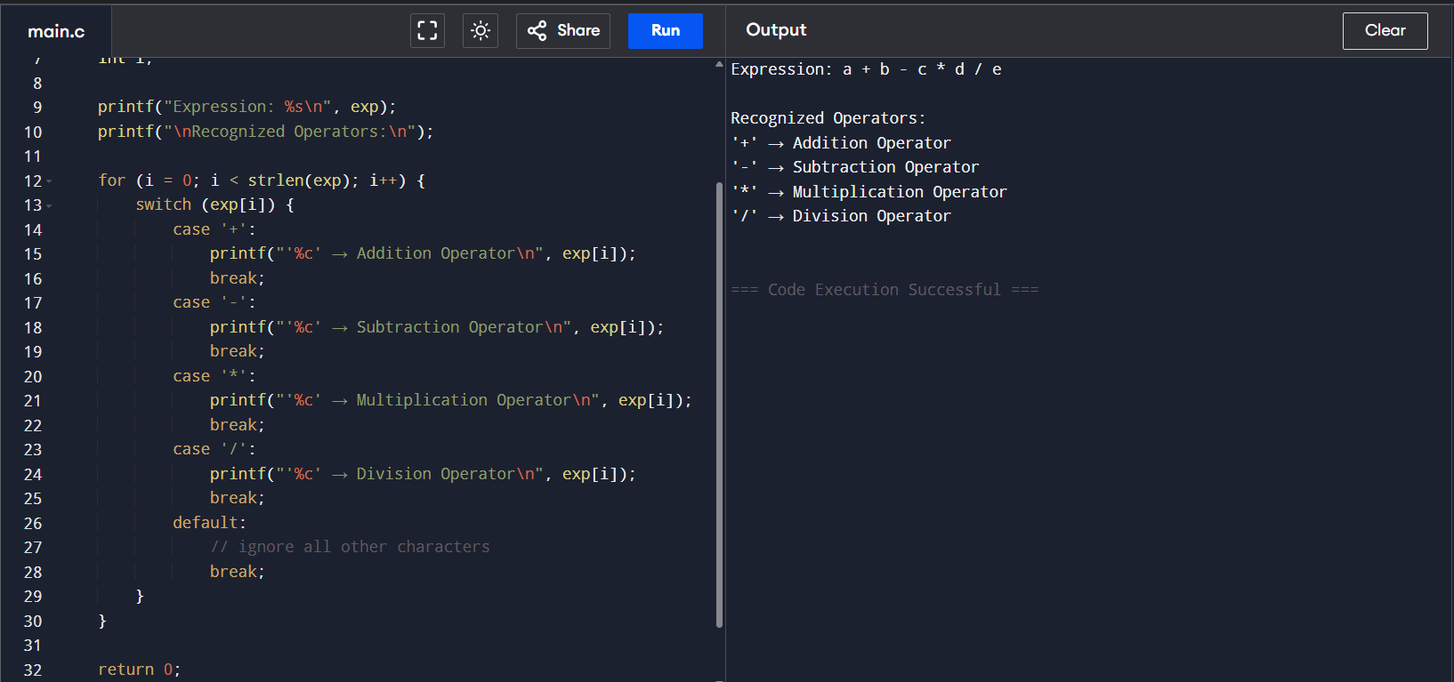
OUTPUT:

4)Lexical Analyzer to Count Whitespaces and Newline Characters in C:

#include <stdio.h>

int main() {
// Input text defined inside the code
char text[] = "Hello world\nThis is a test\nC language";
int i, spaceCount = 0, newlineCount = 0;

// Traverse the text character by character
for (i = 0; text[i] != '\0'; i++) {
if (text[i] == ' ')
spaceCount++;
else if (text[i] == '\n')
newlineCount++;
}

// Display results
printf("Input Text:\n%s\n\n", text);
printf("Number of whitespaces: %d\n", spaceCount);
printf("Number of newlines: %d\n", newlineCount);

return 0;
}

OUTPUT:
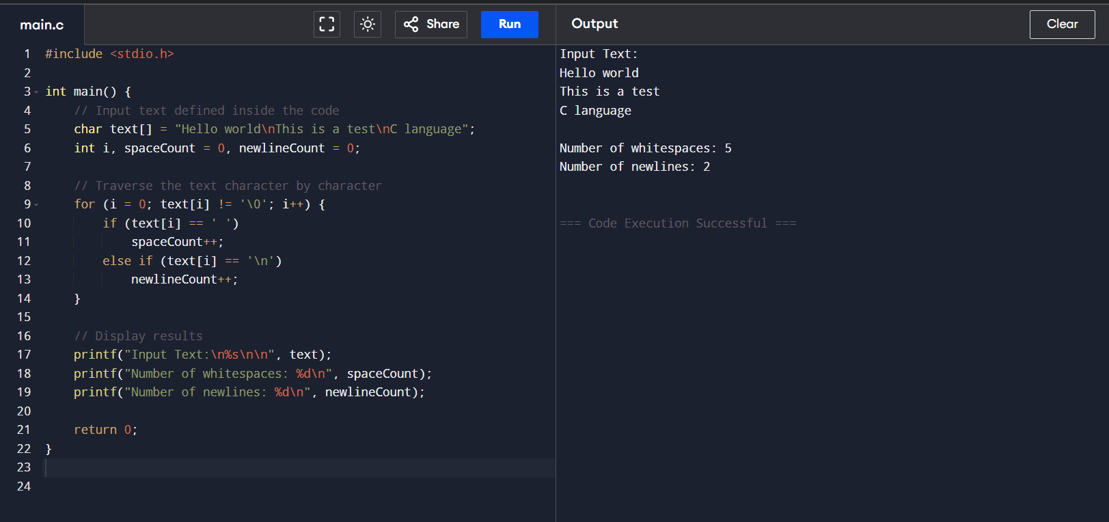

5) Lexical Analyzer to Test Whether a Given Identifier is Valid or Not in C:
#include <stdio.h>
#include <ctype.h>
#include <string.h>
// List of few C keywords to check
char keywords[][10] = {
"int", "float", "char", "if", "else", "while", "for", "do", "return", "void"};
// Function to check if a string is a keyword
int isKeyword(char str[]) {
for (int i = 0; i < 10; i++) {
if (strcmp(str, keywords[i]) == 0)
return 1; }
return 0;}
// Main function
int main() {
// Input defined inside the code
char id[] = "_abc12";
int i, valid = 1;

printf("Given identifier: %s\n", id);

// Check first character
if (!(isalpha(id[0]) || id[0] == '_')) {
valid = 0;
} else {
// Check rest of the characters
for (i = 1; id[i] != '\0'; i++) {
if (!(isalnum(id[i]) || id[i] == '_')) {
valid = 0;
break; }
}
}
// Final check
if (valid) {
if (isKeyword(id))
printf("→ Invalid identifier (it is a keyword)\n");
else
printf("→ It is a valid identifier.\n");
} else {
printf("→ Invalid identifier.\n"); }
return 0;
}

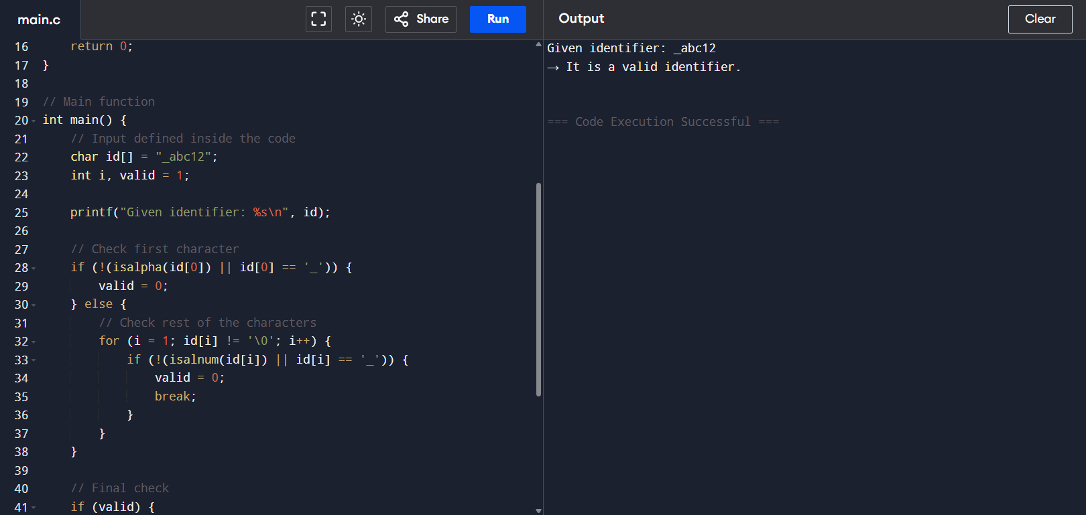
OUTPUT:

6) Implementation of a C Program to Eliminate Left Recursion:

#include <stdio.h>
#include <string.h>

int main() {
char input[] = "A->Aa|b", lhs, alpha[10][10], beta[10][10];
int i=3,j=0,k=0,l;

lhs = input[0];

while (input[i]!='\0') {
if (input[i]=='|') { i++; continue; }
if (input[i]==lhs) {
i++; l=0;
while (input[i]!='|' && input[i]!='\0') alpha[j][l++]=input[i++];
alpha[j][l]='\0'; j++;
} else {
l=0;
while (input[i]!='|' && input[i]!='\0') beta[k][l++]=input[i++];
beta[k][l]='\0'; k++;
}
}

printf("Given Production: %s\nAfter eliminating left recursion:\n", input);

printf("%c->", lhs);
for (i=0;i<k;i++){ printf("%s%c'",beta[i],lhs); if(i!=k-1) printf("|"); }

printf("\n%c'->", lhs);
for(i=0;i<j;i++) printf("%s%c'|",alpha[i],lhs);
printf("ε\n");

return 0;
}

OUTPUT:

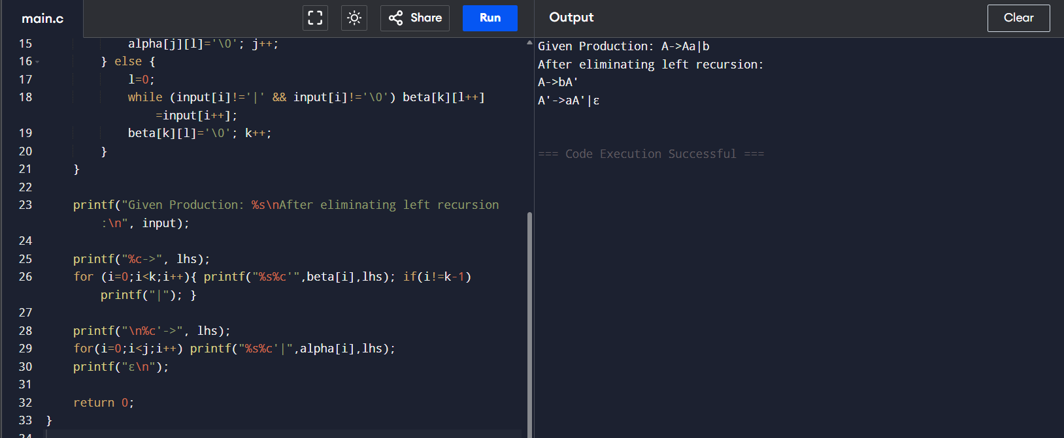

7) Lexical Analyzer to Eliminate Left Factoring:

#include <stdio.h>
#include <string.h>

int main() {
char input[] = "A->ab|ac|ad";
char lhs = input[0];
char rhs[10][10];
int i=3, j=0, k=0, l=0;

// Separate RHS by '|'
while (input[i]!='\0') {
if (input[i]=='|') { rhs[j][l]='\0'; j++; l=0; i++; continue; }
rhs[j][l++] = input[i++];
}
rhs[j][l]='\0'; j++; // total productions = j

// Find common prefix
char prefix[10];
int p = 0;
while(1) {
char c = rhs[0][p];
int same = 1;
for(int x=1;x<j;x++)
if(rhs[x][p]!=c) { same=0; break; }
if(!same || c=='\0') break;
prefix[p] = c; p++;
}
prefix[p]='\0';

// Print result
printf("Given Production: %s\nAfter left factoring:\n", input);
printf("%c->%sA'\n", lhs, prefix);
printf("A'->");
for(i=0;i<j;i++) printf("%s%s", rhs[i]+p, (i!=j-1)?"|":"");
printf("\n");

return 0;
}

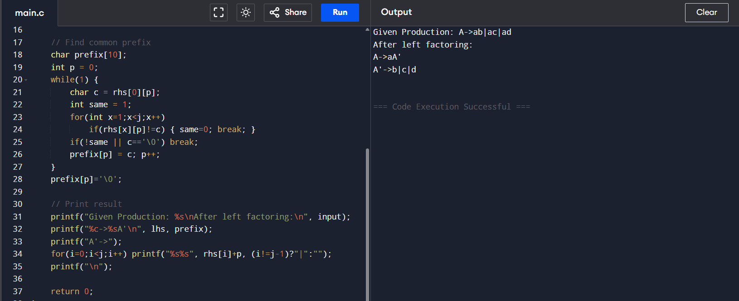
OUTPUT:

8) Implementation of Symbol Table Operations in C:

#include <stdio.h>
#include <string.h>

#define MAX 10

int main() {
char symbolTable[MAX][20]; // Symbol table array
int n = 4; // Number of identifiers
int i;

// Predefined identifiers
strcpy(symbolTable[0], "int");
strcpy(symbolTable[1], "sum");
strcpy(symbolTable[2], "total");
strcpy(symbolTable[3], "count");

printf("Inserted Identifiers:\n");
for(i=0;i<n;i++)
printf("%s\n", symbolTable[i]);

// Search examples
char search1[] = "sum";
char search2[] = "average";
int found = 0;

for(i=0;i<n;i++)
if(strcmp(symbolTable[i], search1)==0) { found=1; break; }
printf("\nSearch for '%s': %s\n", search1, found?"Found":"Not Found");

found = 0;
for(i=0;i<n;i++)
if(strcmp(symbolTable[i], search2)==0) { found=1; break; }
printf("Search for '%s': %s\n", search2, found?"Found":"Not Found");

return 0;
}

OUTPUT:

